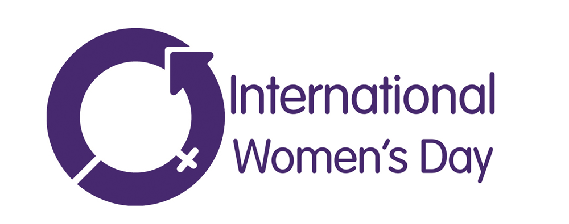

Primary School – Lesson Plan

This activity has been designed to introduce students to the gender pay gap and the theme of gender inequality.

Students will consider ways that they can incorporate the values of International Women’s Day into their day so that the world can be ‘Balanced for Better’.

There are 3 parts to this lesson plan. Depending on the time available these can be used together, or as standalone activities.

Objectives:
Students will understand the role they play in achieving gender equality

Outcomes:
Students should be able to relate their understanding and knowledge of this topic to real-life examples and behaviours.

Materials:

- 16 x printed £1 coins (or a reward in-line with your class reward system)
- Accompanying International Women’s Day PowerPoint Presentation
- Paper, Pens, Drawing Materials and Laptops if you wish to do a PowerPoint presentation for Part 3

Part 1
Activity - 5 minutes

- Ask one female student and one male student to hand out the worksheets for Part 3 of this task. Before they begin, explain to the two students that they will receive some fake money as ‘payment’ for the task.
- Give the female student two-thirds of the worksheet and the male one-third of the sheets to hand out. Explain to the full class that you have distributed the work in that way.
- Once they have finished, hand the male £10 of fake money and the female £6 of fake money (you can substitute these values in-line with the rewards you give your class, just ensure that the ratios are similar. For example, the male may be rewarded with 10 minutes of golden playtime, but the girl only 6 minutes).
- After you have rewarded the students explain that even though the female did more work, you are rewarding the male £10 because that reflects how women are paid in society; for every £10 a male is paid, women are paid (on average) £6 of that.

Explain that what they have just witnessed is something that happens every day in society part of the inequality that International Women’s Day is trying to address is the fact that currently women do two-thirds of the world’s work, but are only receive 60% of the pay that men receive, and is called ‘The Gender Pay Gap’.

Part 2
Class Discussion - 20 minutes

Write ‘Equality’ ‘Discrimination’ and ‘Bias’ on the whiteboard.

- Ask the class to explain what they believe each of these words mean.

Summarise their answers with:
Equality – Equality is when everyone is treated fairly. It doesn’t mean that everyone is treated the same.

Discrimination – treating a certain group of people differently or unfairly – especially if you are treating them worse than you would treat other people.

Bias – supporting or opposing someone in an unfair way because you have allowed personal opinions to influence your judgement.

- Ask the boy how he feels about the fact that he did less work and got paid more

- Ask the girl how she feels about doing more work but getting paid less

- Ask the class how they would feel if they were in that situation – do they believe it is discrimination?

- Ask them to explain their answers and describe why they feel that way

- Ask them if they have any ideas that they can create equality.

To summarise, explain that the gender pay gap is just one way that women and girls experience inequality, which is why it is important that we take time to reflect on how we can ensure that men and women are treated fairly and equally in society.

Part 3 – Task – 30 minutes

Divide your students into groups of 3 or 4 (this task can also be completed individually if you would prefer).

Ask them to choose one of the 10 values for International Women’s Day and something from the list to design that will communicate that value to the people reading it.

Remind them that their completed work should encourage the person reading it to do their bit for equality.

Create a display of the work so other classes can enjoy and learn from what your class have produced! We love to see these activities come to life – share a picture

