Pride Ally Flag (55 minutes)

Objective:

Pupils will learn about what an LGBT+ ally is and how they can be one.

Materials:
- Plain A4 or A3 card (to create the flag)
- Red, orange, yellow, green, blue and purple art supplies to decorate the flag with. E.g. glitter, felt, card, feathers, felt tips, paint or sequins.

Task details:

- Part One - Time: 15 minutes
Read to pupils the intro, what an ally is and why it is important. Next, go through the examples of how you can be an ally.

- Part Two - Time: 10 minutes
Ask pupils if they have any other ideas how you can be an ally?

- Part Three – Time: 30 minutes
Then ask pupils to decorate their flag with words associated with being an ally and the pride colours. Encourage students to be creative with their flags e.g. using glitter, feathers, sequins or fabric.

  - We would love to see pictures of your creations! Tweet @tootootofficial or email support@tootoot.co.uk
  - Pride Ally Flag
Intro
In June cities and towns around the world celebrate Pride, by having events and parades. The purpose of Pride is to celebrate the progress the LGBT+ community have made, but also recognise the distance still to go to achieve full equality.

Allies can help the LGBT+ community get closer to full equality.

During this exercise you will find out what it means to be an ally and create your own Pride Ally Flag.

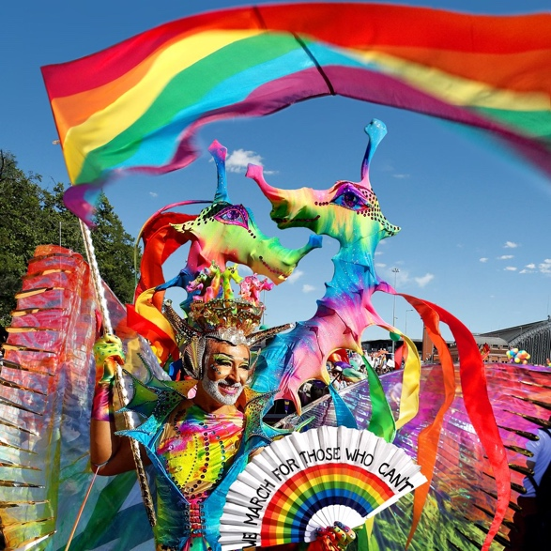
Pictures from Pride parades around the world
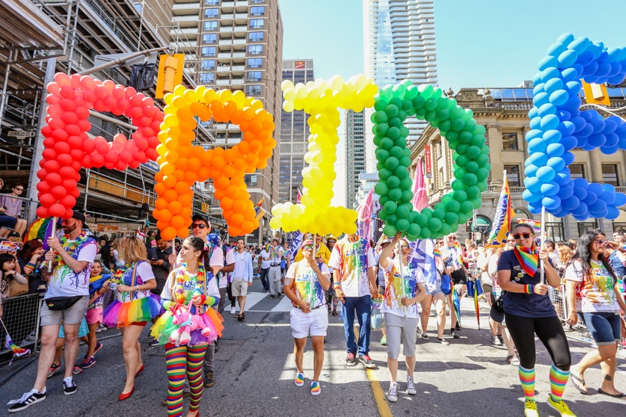

Part 1
What is an LGBT+ Ally?

An ally is someone who is kind and supportive to LGBT+ people. You do not have to be LGBT+ yourself to be an ally - anyone can be an ally.

Why be an Ally?

Students who are LGBT+ are more likely to be bullied and by showing your support you can make a big difference. Allies help LGBT+ students feel safer and more included in school.

How can you be an Ally?

- Be a good listener
- Be kind
- Be open-minded
- Be willing to talk
- Do not use offensive language
- Stand up for your LGBT friends if they are being discriminated against
- Use tootoot to report LGBT+ bullying
- If you hear anti-LGBT jokes tell the person that it is harmful and offensive

Part 2

Create a list of how you will be an ally using the list given and your own ideas

………………………………………………………………………………………………………………………….………………………………………………………………………………………………………………………….………………………………………………………………………………………………………………………….………………………………………………………………………………………………………………………….
………………………………………………………………………………………………………………………….………………………………………………………………………………………………………………………….

Part 3
Task

- Using A4/A3 card create your own Pride flag in the order of the colours below.
(You could use pencils or paint or felt tips or crayons)
Red
Orange
Yellow
Green
Blue
Purple

- Next choose your favourite ways to be ally from the list you created and write them on the flag.
- Finally put the finishing touches on decorating your flag. For example, you could use glitter, sequins, felt or fabric.

