The Media and Mental Wellbeing

It’s important for mental wellbeing that pupils are able to make the distinction online between what’s real and what’s not. As fake news and misleading advertising can negatively impact self-esteem, body image and mental health.

Objective: Pupils will evaluate why advertising and social media posts can be misleading and the effect on mental wellbeing.

Materials:
- Printed worksheet
- Pens

Total Time: 30 minutes

Part One – 15 minutes
- Read the introduction to pupils.
- Ask pupils to complete task one.
  - Make sure that each image has been researched by at least one pupil.

Part Two – 15 minutes
- Ask each pupil to present their work to the class
  - Ask pupils if they found any images particularly shocking? Or were they not surprised?
  - Ask pupils what do they think should be done to regulate the media and avoid more adverts and posts like the examples given in the future?

The Media and Mental Wellbeing - Worksheet

Introduction
Our mental wellbeing can be affected by what we see online. For example, pictures you see on Instagram can influence what you perceive as a ‘normal’, or sensationalised fake news can leave people feeling confused or panicked. Therefore, it’s important that we are able to critique and evaluate what we see online.

Task One
On the next few pages there are 8 examples of fake news stories, misleading advertisements and fake Instagram posts.

- Pick 2 images to evaluate and answer questions a & b.
  - Why is this image misleading?
Image Number:

Image Number:

  - How could this image negatively affect an individual’s mental wellbeing?

Image Number:

Image Number:

1.
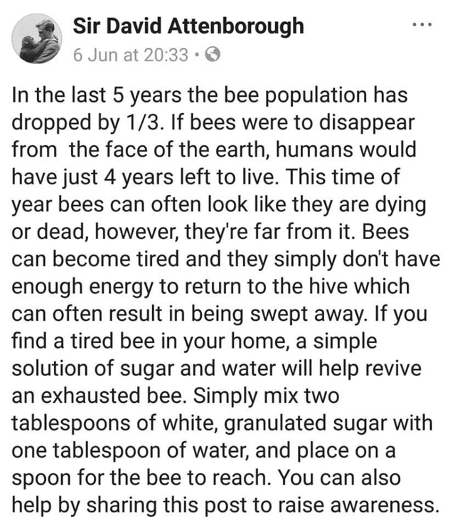

2.
3.
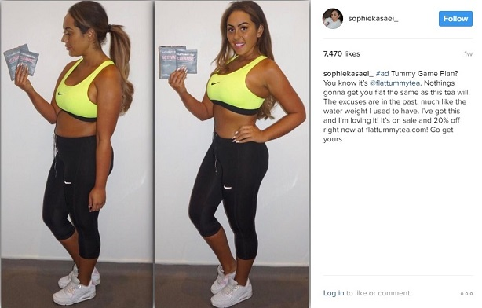

4.
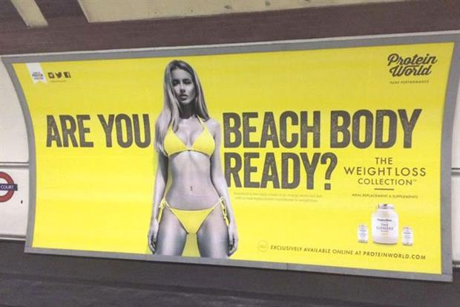

5.

6.

7.
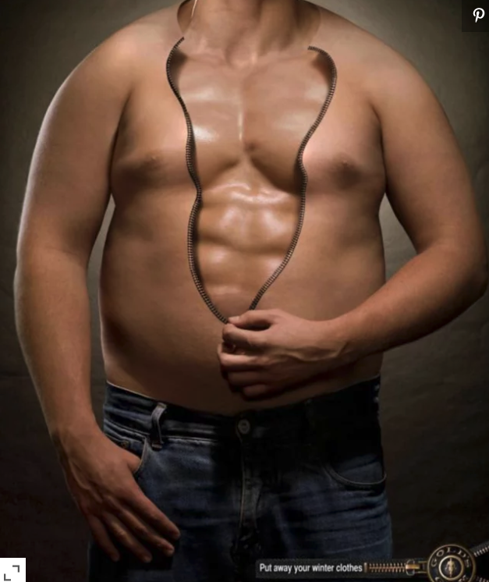

8.
