Design a Christmas Jumper

Time: 20 minutes

Materials:
Printed worksheets
Crayons
Felt tips
Decorations (felt, sequins, glitter etc.)
Scissors

Task
- Hand out worksheets
- Ask pupils to design their own Christmas jumper

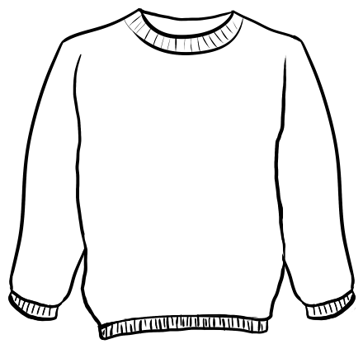
Christmas Jumper Worksheet
Design your very own Christmas Jumper, be as colourful and creative as you like!

