The Media vs. Reality

In part one of this activity pupils will be examining the way images in the media make them feel. Then in part two pupils will explore the ways images can be manipulated and edited.

Objective: Pupils will begin developing the self-reflective skills they need to make objective judgements about the images shown in the media.

Materials:
- Printed worksheets (pupils will be in groups of four and will share worksheets)
- Pens

Total Time 50 minutes
Part One (20 minutes)

- Split the class into groups of four and give each group a set of the worksheets.
Try to make sure each group is mixed gender.
- Ask pupils to look through the images in Group 1 and discuss as a group how the images make them feel. Then write down words relevant to their feelings underneath each image.
- Discuss the images in Group 1 as a class and ask each group to present what they wrote down for one of the images.

Part Two (20 minutes)

- In the same groups, ask pupils to look through the images in Group 2 then discuss and write down changes that have been made to the person.
Tell pupils that there is nothing wrong with the unedited pictures- they are normal! The purpose of this activity is not to encourage body shaming, it is simply to show the difference between what we see in the media versus the reality.

- Discuss the images in Group 2 as a class and ask each group to present what they wrote down for one of the images.

Part Three – Reflection (10 minutes)

- Ask the class to reflect back on their group discussions think about why it is important to be a critical viewer of social and media messages.

The Media vs. Reality Worksheet

Images – Group 1
Image 1a

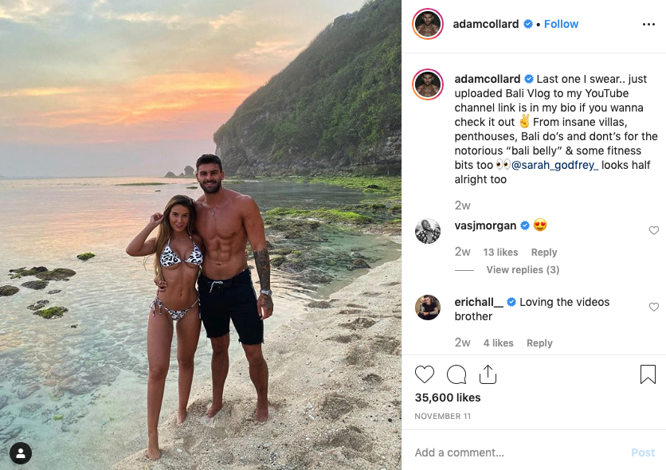

Image 1b

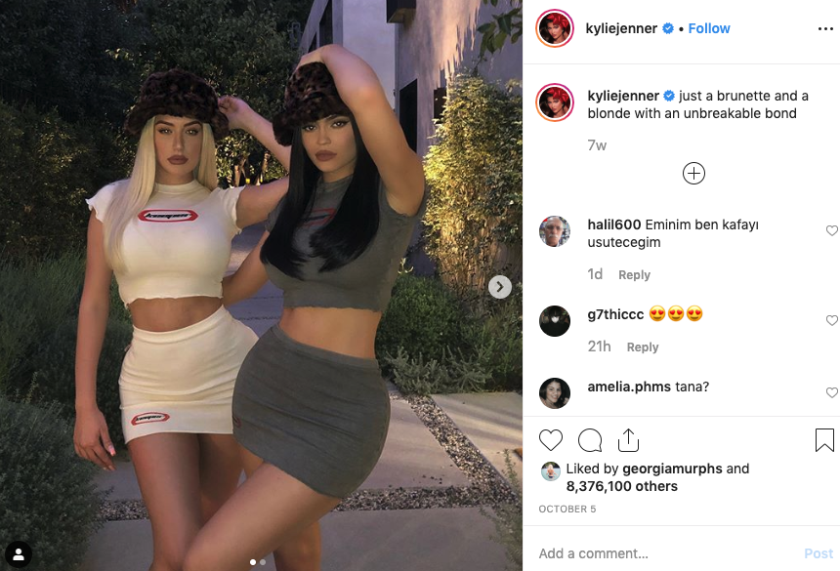

Image 1c

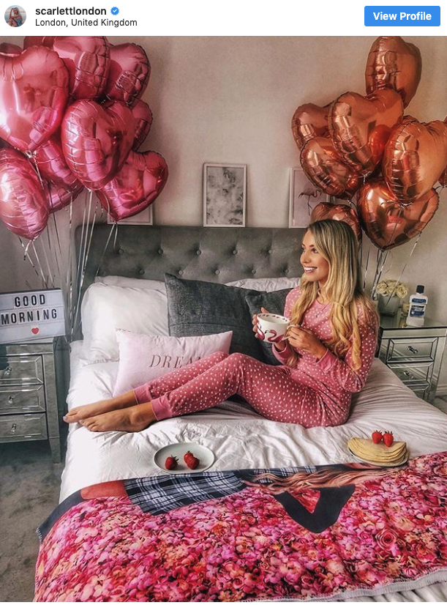

Image 1d

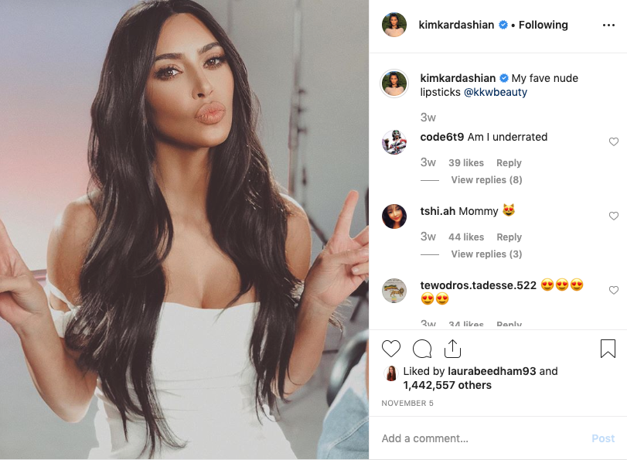

Image 1e

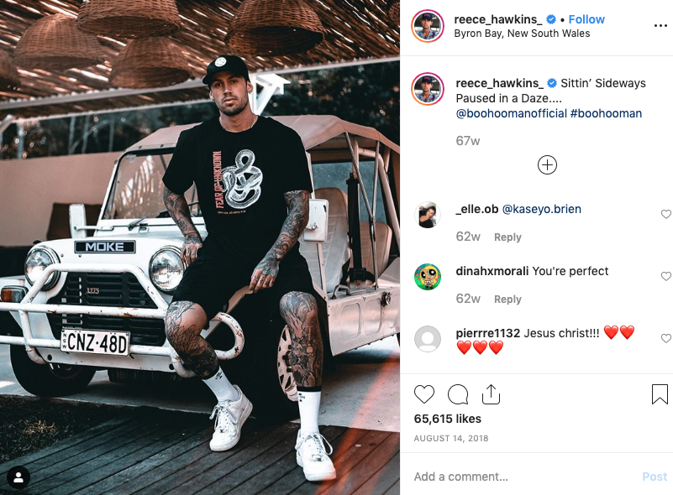

Image 1f

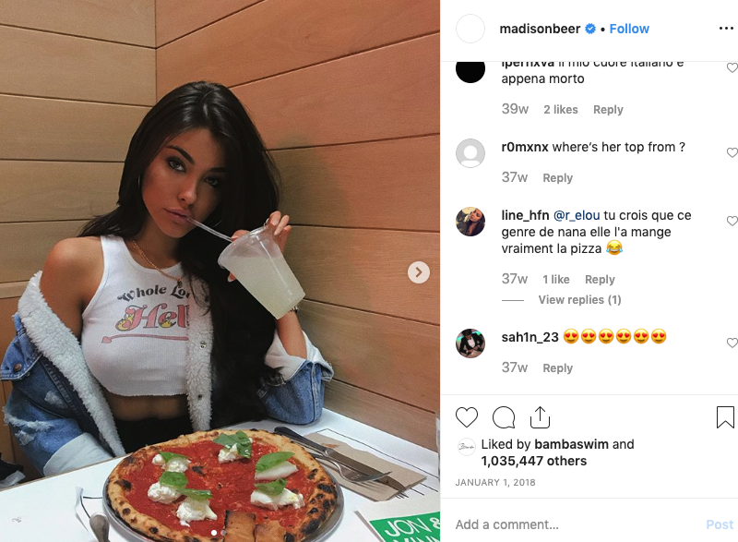

Image 1g

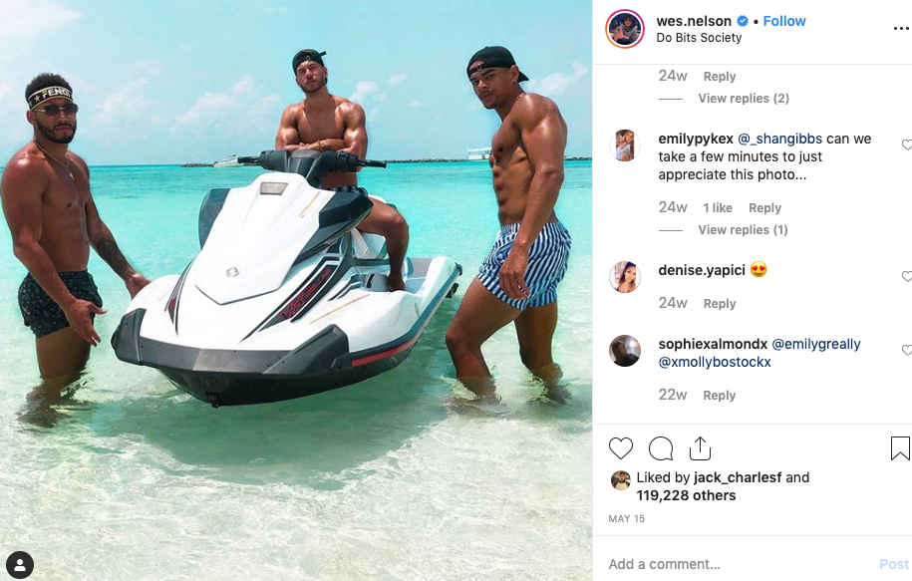

Images – Group 2
Image 2a

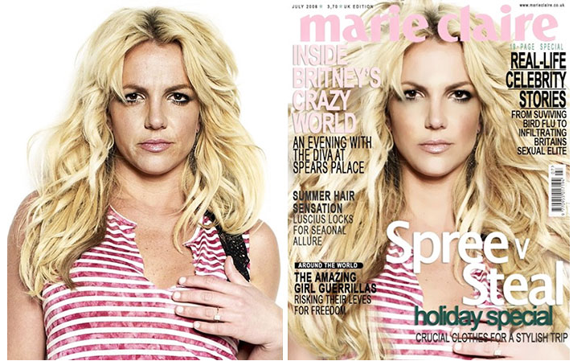

Image 2b

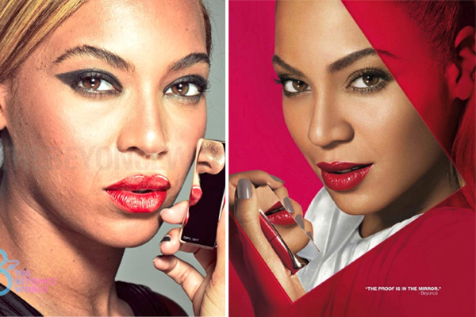

Image 2c

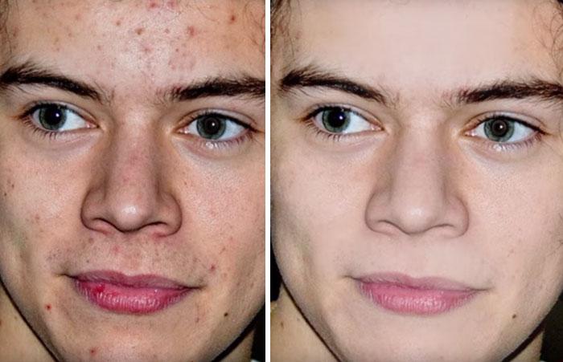
Image 2d

Image 2e

Image 2f

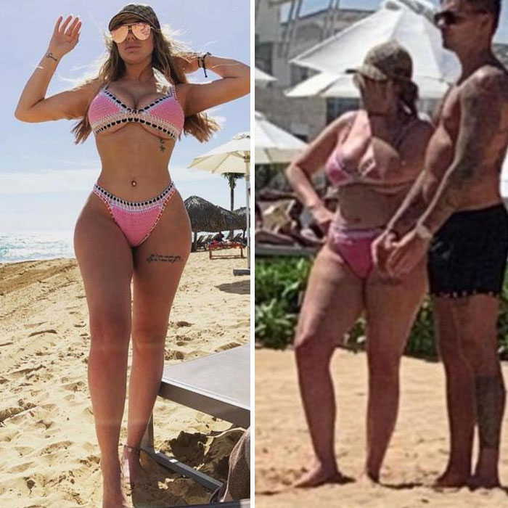

Image 2g

